Kirin Harrington

kirin@twosmallpeople.co.uk

Abstract

[Draw your reader in with an engaging abstract. It is typically a short summary of the document.   
When you’re ready to add your content, just click here and start typing.]

Unit 2 LO4

Khelam Island project – Kirin H

Contents

How well my project meets the breif 2

Self feedback 2

Fonts 2

Colour scheme 2

Sitemap 2

Wireframe 2

Mood board 2

Feedback improvement 2

Pier feedback – Matilda Rawson 3

Sitemap 3

Colour scheme 3

Fonts 3

Mood board 3

Wireframes 3

Feedback improvement 3

Form feedback 4

Fonts 4

Main text 4

Titles 4

Colour scheme 5

Project choice 5

Information format 6

Overall conclusion 6

# How well my project meets the breif

I believe that my design ideas match the brief very well as the brief was to create an interactive product which engages users and brings a wider audience to the museum, and to increase how involved and interactive. My project (VR project) is very exciting for younger children, brings enjoyment to teens and young adults because it allows for a combination of a very visual and immersive experience with a lot of very interesting information on the exhibits in Kelham Island Museum. It can provide a lot of information to older adults, because of this it will reach a very wide demographic and encourages users to visit the museum. It also allows the user to learn a lot more about the exhibits shown in the museum and see them in action.

# Self feedback

## Fonts

I believe fonts went very well. I choose Bauhaus 93 for titles and Agency FB for the rest of the text in my project, I believe these fonts would work very well as they are very easy to read and understand and fit the theme of the project very well in my opinion.

## Colour scheme

I believe my choice of colour schemes work very well, I chose to use a combination of a dark grey gradient and an orange and yellow gradient, I was going to use these together to create the menu of my project, I think they fit the project very well as they fit the industrial theme of steel, and also look very professional and complement each other very well.

## Sitemap

I think my sitemap worked quite well, it shows how the pages fit together and would be a good point of reference when I am creating my project, it is very simple, but it works well and will be very useful when I begin creating my project.

## Wireframe

I think my wireframe could have been improved but it still illustrated how the project would look from the user’s point of view, even though it is quite simple it still shows the layout of the project and will be very useful when creating it.

## Mood board

I like my mood board because it is a good source of information and inspiration which I can draw upon while creating my project, it has a large number of images which provide a good amount of variety and also makes sure I successfully fit the theme of industrial steel making.

## Feedback improvement

I will research how to create good wireframes, and then recreate my current ones so they make more sense when I create my project, I will also add more images to my mood board and look into incorporating another colour scheme in addition to the ones I already have.

# Peer feedback – Matilda Rawson

## Sitemap

They liked my sitemap, they believed that it was very detailed, but also simple and easy to understand

## Colour scheme

They think it needs improvement as it is very monotone, because of this I will research alternatives or find a way to make it more interesting and less plain.

## Fonts

They didn’t like my fonts, the title was hard to read, because of this I shall use a different font such as Bernard MT Condensed, they also didn’t like the font I choose for the rest of the text as it was too thin and hard to understand.

## Mood board

They really liked my mood board because it was related to the brief, had a good selection of colours, and they think it will provide a lot of inspiration when I created the project.

## Wireframes

They found my wireframes hard to understand, because of how difficult it is to display a 3d environment in a 2d image, but they like the layout how it all works together.

## Feedback improvement

I will research better colour schemes, find easier to read and more pleasing fonts, and improve my wireframes.

# Form feedback

## Fonts

### Main text

In my design document I planned to use Agency FB as the font for the majority of text in my project. Most of the people who conducted my survey choose that they liked Agency FB the best, but Cavolini was a close second, I plan to incorporate both in my project by adding an option to change the font of the text in the settings menu of the project.

The results of my survey are shown below.

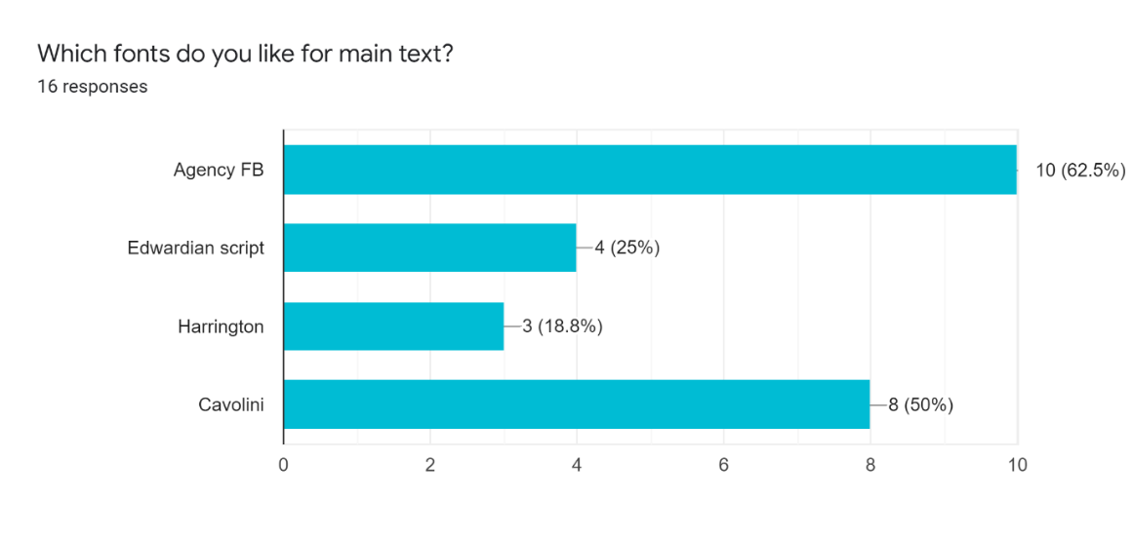

### Titles

In my design document I planned to use Bauhaus 93 as the font for titles in my project, however, the results of the survey showed that people overwhelmingly preferred Bernard MT Condensed. Because of these results I have decided to change my plans and use Bernard MT condensed because of how popular it is, I will add an option to use Bauhaus 93 in the settings of the project because, even though it’s less popular, quite a few people still liked it.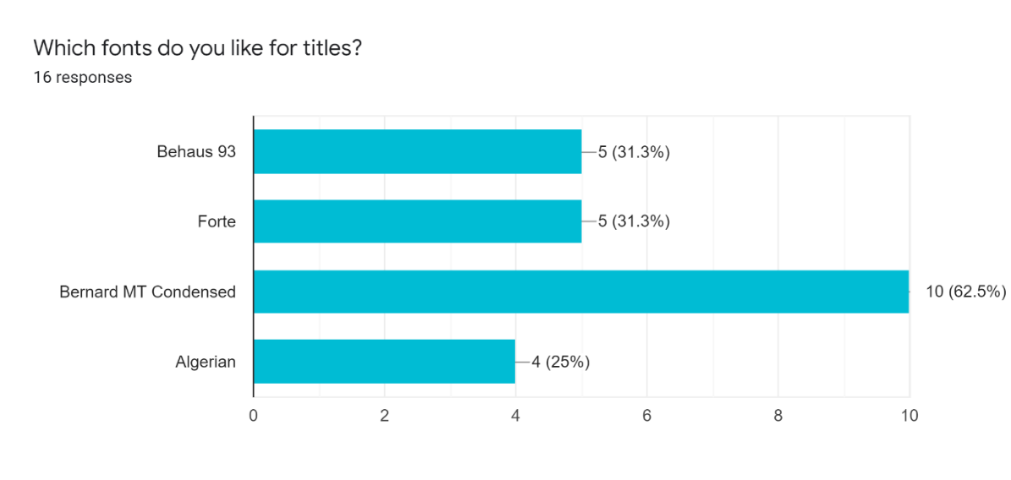

## Colour scheme

In my design document I planned to use a combination of the dark grey gradient and the orange and yellow gradient, the results of my survey confirmed that they were the two most popular colour schemes, but the dark grey gradient has a considerable lead, because of this I will still incorporate both into my project but I will focus much more on the dark grey gradient for menus, with small elements of orange and yellow gradient to provide a splash of colour and break up the otherwise very grey look of the menus. 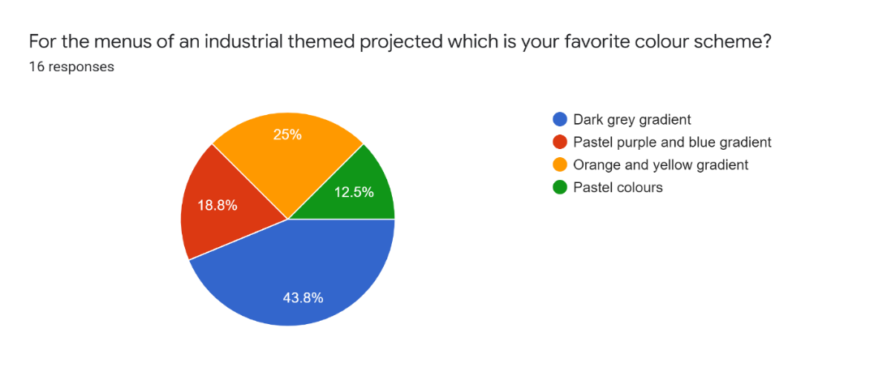

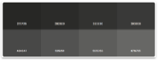 - Dark grey gradient

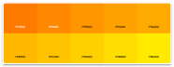 - Orange and yellow gradient

## Project choice

I decided to create a virtual reality experience for my virtual reality project, I asked the people who filled out my survey if they would use a virtual reality exhibit when they visited a museum. The vast majority of people said they would be very likely to use the project. It also followed the trend I predicted, everyone who said they would be unlikely to use it were over 50 years old, and the younger people were the more likely they are to use the exhibit. Because so many people said they would use it, I shall continue with my plans to create a virtual reality project.

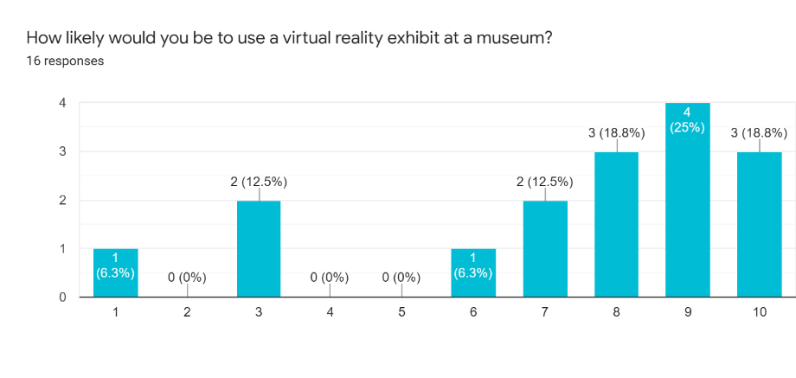

## Information format

I planned originally to present information to user with the use of moving machinery which could be seen in the virtual reality environment, but also add text pop-ups to provide extra information about the machine that was currently being viewed. I asked the people who filled out my survey how they preferred to view information. The most prominent answers were images and text, which fits with my original plan of using text pop-ups, I was surprised to see how much people wanted images, but because of this I will incorporate images into the pop-ups to provide extra information.

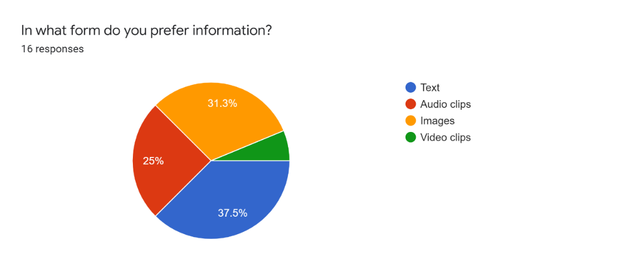

# Overall conclusion

I am very pleased with my design document, I really like the layout I have chosen, as it looks very professional, I also like my sitemap as it effectively illustrates how different parts of the product will work together and will be a great aid when I begin creating it. I also like fonts I have chosen as they link to the brief and are easy to read and understand for everyone. I found making a colour scheme challenging as I am not very good at finding colours that work well together, I also struggled with the assets section as I am not entirely sure of what assets I need, as every aspect of the product requires assets due to it being a VR project. I think I could greatly improve my wireframe as it is quite basic and doesn’t illustrate the look of the project very well, it would greatly help if I improved it because I will be using it as a reference when creating my product, I also think I could improve my mood board by adding more images and a greater variety of images, this would be helpful as it will provide more sources of inspiration and will help in the creation of my project.